**T**

DCN LAB FINAL PROJECT

**MEMEBERS**

**COLLEGE**

**NETWORKKK**

P R O J E C T R E P O RT

**CAMPUS**

**BAHRIA**

**UNIVERSITY**

**ISLAMABAD**

**TABLE OF** OF

04

05

06

07

09

10

SUMMARY

08

ROUTING PROTOCOL PLN

IP ADDRESSING PLAN

03

NETWORK REQUIREMENTS

02

OBJECTIVES

INTRODUCTION

01

**CONTENTS**

NETWORK DEVICES

IP CONFIGURATION

SECURING ROUTES

REFERENCES

**01. INTRODUCTION**

This College Network Scenario is about designing a topology of a network that is a LAN (Local Area Network) for a college in which various computers of different departments are set up so that they can interact and communicate with each other by interchanging data. To design a networking scenario for a college which connect various departments to each other’s, it puts forward communication among different departments. CNS is used to design a systematic and well-planned topology, satisfying all the necessities of the college (i.e. client). CNS come up with a network with good performance.

**02. OBJECTIVES**

The main objective of the proposed network design for the college is to modernize the existing network infrastructure, enhancing its overall capabilities and increasing its flexibility to meet the evolving needs of the institution. By updating the network, the aim is to significantly improve performance, ensuring faster data transmission and reliable connectivity across various departments. This enhancement will support a higher volume of devices and applications, facilitating seamless communication and collaboration among students, faculty, and administrative staff.

**03. NETWORK REQUIREMENTS**

1. The new system should be able to reduce internet downtime. Download and upload links should be.
2. maintained above 5 Mbps speed requirement.
3. The network will be scalable.
4. The system should support remote access.
5. Should comprise of data centers with necessary security features and support.

**04. NETWORK DEVICES**

**Devices Used in The Network**

|  |  |
| --- | --- |
| Devices | Quantity |
| Servers | 3 |
| Routers | 3 |
| Switches | 5 |
| PCs | 15 |
| Laptops | 1 |
| Tablets | 1 |
| Smart Phones | 1 |
| Printers | 3 |

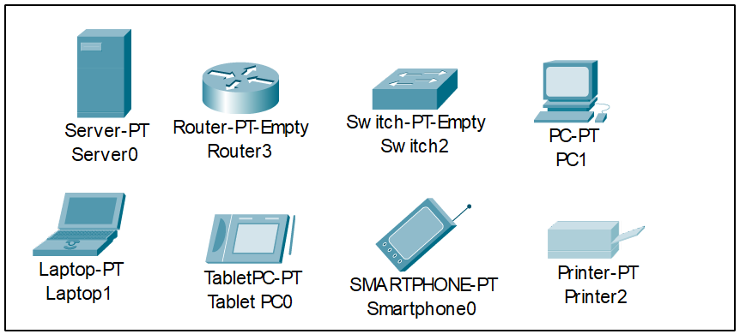

**05. IP ADDRESSING PLAN**

|  |  |
| --- | --- |
| **IT DEPARTMENT (192.168.1.0)** | |
| IT INSTRUCTOR | 192.168.1.2 |
| IT LAB 1 | 192.168.1.3 |
| IT LAB 2 | 192.168.1.4 |
| IT LAB 3 | 192.168.1.5 |
| IT LAB 4 | 192.168.1.6 |
| PRINTER 0 | 192.168.1.7 |

|  |  |
| --- | --- |
| **CS DEPARTMENT (192.168.2.0)** | |
| CS INSTRUCTOR | 192.168.2.2 |
| CS LAB 1 | 192.168.2.3 |
| CS LAB 2 | 192.168.2.4 |
| CS LAB 3 | 192.168.2.5 |
| CS LAB 4 | 192.168.2.6 |
| PRINTER 7 | 192.168.2.7 |

|  |  |
| --- | --- |
| **SERVER ROOM (1.0.0.0)** | |
| FTP SERVER | 1.0.0.4 |
| DNS SERVER | 1.0.0.2 |
| WEB SERVER | 1.0.0.3 |

|  |  |
| --- | --- |
| **INTERNET LAB (192.168.0.0)** | |
| LAB PC2 | 128.168.0.2 |
| LAB PC3 | 128.168.0.3 |
| LAB PC4 | 128.168.0.4 |
| LAB PCS5 | 128.168.0.5 |
| PRINTER 5 | 128.168.0.6 |

|  |  |
| --- | --- |
| **PRINCIPAL ROOM (192.168.4.0)** | |
| PC 0 | 128.168.4.2 |
| LAPTOP 0 | 128.168.4.3 |
| SMARTPHONE1 | 128.168.100 |
| TABLE PC 1 | 128.168.0.101 |

**07. IP CONFIGURATION**

We have attached the screenshots of all the IP configuration below:

**Router 0**

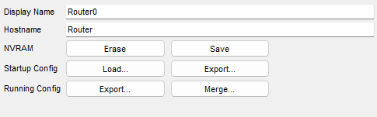

**FastEthernet0/0**

**FastEthernet1/0**

**Serial2/0**

**RIP**

**Router 1**

**FastEthernet0/0**

**FastEthernet1/0**

**Seria2/0**

**Seria3/0**



**RIP**

**Router 2**

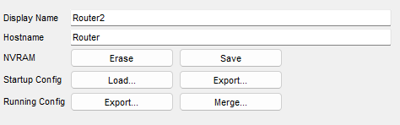

**FastEthernet0/0**

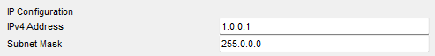

**FastEthernet1/0**

**Serial2/0**

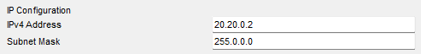

**RIP**

**FTP Server**

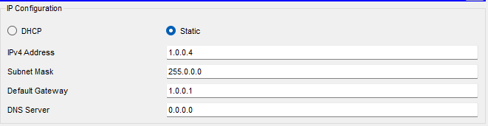

**WEB Server**

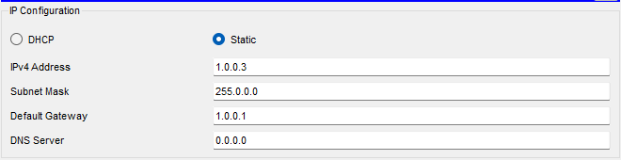

**DNS Server**

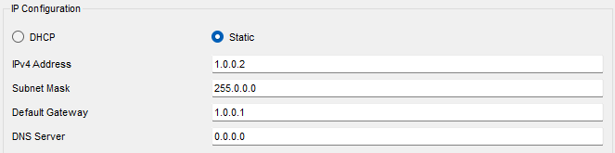

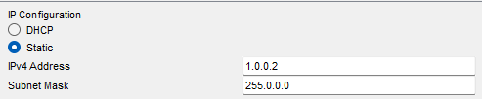

**06. ROUTING PROTOCOL PLAN**

Routing Information Protocol (RIP) is a dynamic routing protocol which uses hop count as a routing metric to find the best path between the source and the destination network. It is a distance vector routing protocol which has AD value 120 and works on the application layer of OSI model.

Router 0:

**Router 1**

**Router 2**

**07. SECURING ROUTERS**

Routers are also secured with ssh (Secure Shell). Routers and their assigned passwords are mentioned below:

|  |  |
| --- | --- |
| Routers Name | Passwords |
| Router 0 | SSH (admin) |
| Router 1 | SSH (admin) |
| Router 2 | SSH (admin) |

**Router 0**

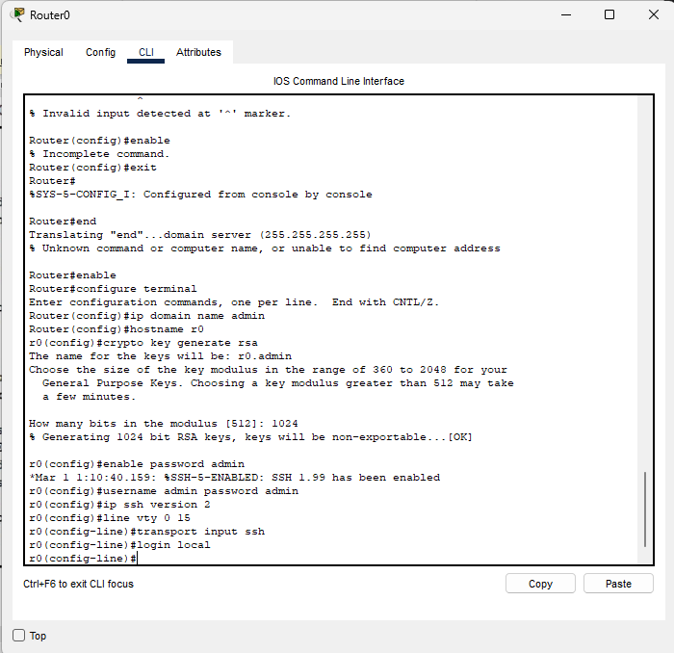

**Router 1**

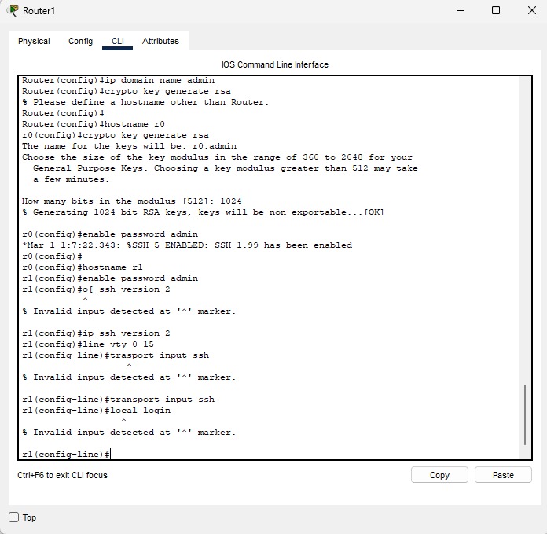

**Router 2**

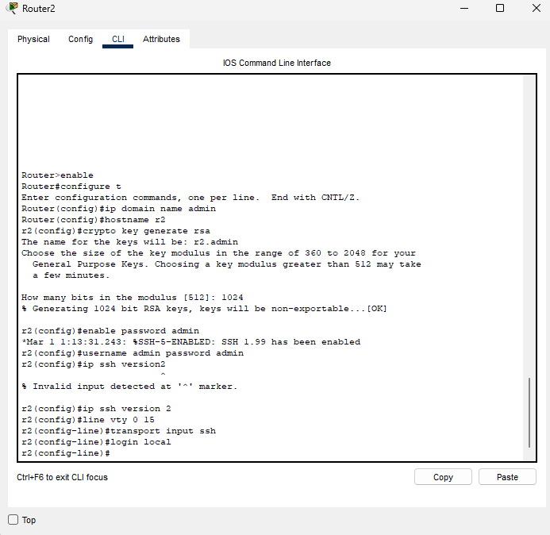

**08. DESIGN, PING TEST, SIMMULATION**

**Network Design**

**Ping test**

**Simulation**

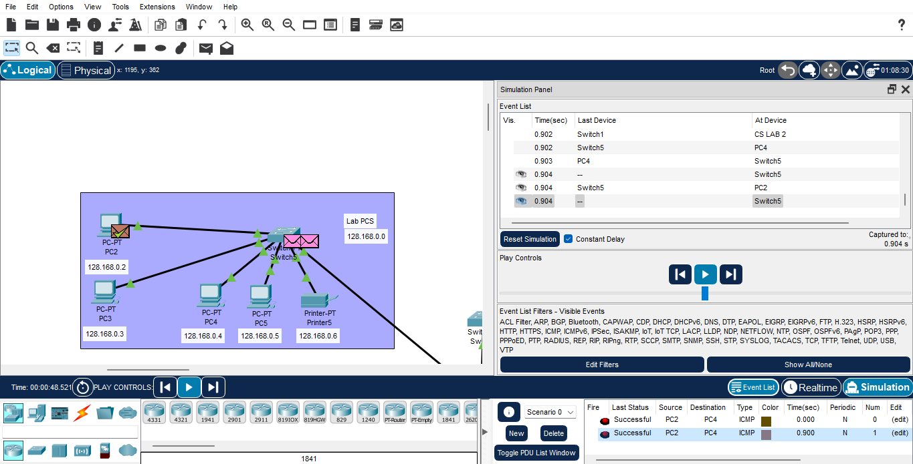

**09. SUMMARY**

The outcome of the proposed system will be a fail-safe backbone network infrastructure which meets the requirements for readily available access to information and security of the private network and ensures optimized productivity when telecommunication services are accessed. The installed equipment allowed to organize high-speed wired and wireless Internet access throughout the whole complex of hospital buildings as well as providing transfer of all types of data throughout the single optimized network.

**10. REFERENCES**

1. Sun, L., Wu, J., Zhang, Y., & Yin, H. (2013, April). “Comparison between physical devices and simulator software for Cisco network technology teaching”. In Computer Science &Education (ICCSE), 2013 8th International Conference on (pp. 1357-1360). IEEE
2. Roberto Minerva Abiy Biru, "Towards a Definition of the Internet of Things” IEEE IOT Initiative white paper.
3. “Design and Simulation of Local Area Network Using Cisco Packet Tracer”. The International Journal of Engineering and Science (IJES) || Volume || 6 || Issue || 10 || Pages || PP 63- 77 || 2017 || ISSN (e): 2319 – 1813 ISSN (p): 2319 – 1805.
4. Qin, X. U. E. "Simulation Experimental Teaching of Computer Network Based on Packet Tracer [J]." Research and Exploration in Laboratory 2 (2010): 57-59.
5. Current, John R., Charles S. ReVelle, and Jared L. Cohon. "The hierarchical network design problem." European Journal of Operational Research 27.1 (1986): 57-66.